# HTML – Lab

We will use lab time today to translate your drawn-out element hierarchy into HTML code. The goal of this exercise is to have you think architecturally and semantically.

## Software Requirements

* Text Editor
* Browser

## Instructions

1. Start by taking the drawn-out HTML mapping you did earlier in the class.
2. Translate this mapping into HTML code. If you didn’t already do so, try to be as semantic as possible when choosing element types.
3. Copy and paste the actual content from the website into your code.
   1. Create new paragraph elements for each new paragraph of text.
4. Replace the original navigation links with links to different paragraphs throughout the article.
   1. Give the paragraphs you choose IDs that you can use when defining the ‘href’ attribute of the navigation link.
   2. It’s not important which paragraphs you choose to link to – the point is to practice linking to different parts of the article using fragments.
5. If you have time, start thinking about and assigning classes to elements that you would style similarly. Don’t worry about actually styling them for now – we’ll get to that in the next class.
6. You can check your work by opening the HTML file in your browser – dragging the file into your browser usually does the trick for this.
7. Save your HTML file – we’ll be using it again in the next class.

## Github

We will use Git throughout this class to share code with you and to collect homework from you. Github is a service that makes using git easier and more extensible.

If you don’t already have an account, please sign up for one here: [www.github.com](http://www.github.com).

You will have to set up some keys and files on your computer to allow your computer and Github to communicate with each other.

First, let’s configure some settings: [https://help.github.com/articles/set-up-git/.](https://help.github.com/articles/set-up-git/)

Second, let’s configure some security keys to allow Git and Github to communicate: <https://help.github.com/articles/generating-an-ssh-key/>.

To access the IOLab repository, visit this link: <https://github.com/vijayv/IOLab>. On the top right hand corner of the page, click on the “Fork” button to create your own copy of this repo.

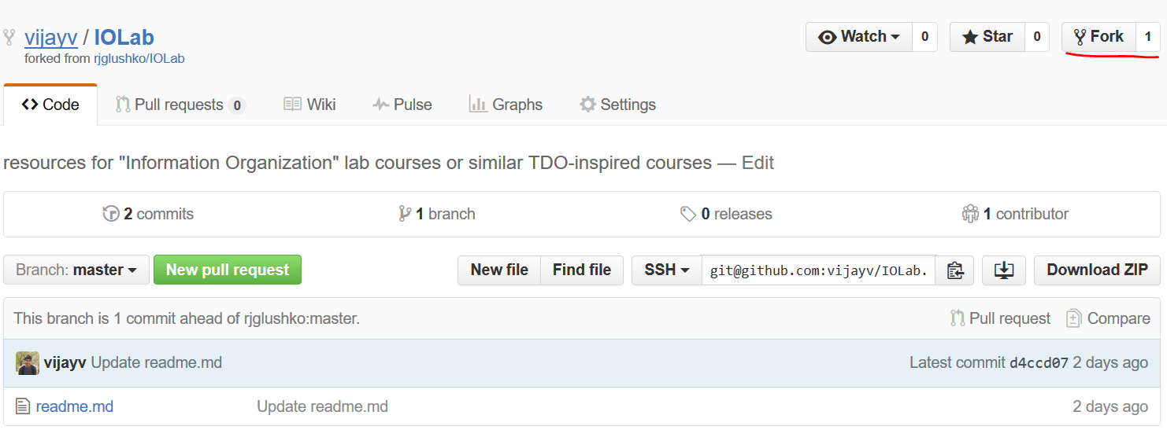

Finally, navigate to the desktop (or, any other convenient location) on your computer using the command line, and clone your newly “forked” repository to your computer. You can do this by using the git clone command and pass it the url to your forked repository like in the example below.

git clone git@github.com:vijayv/IOLab.git

Ensure that you replace the url above with the url for your own repository. You can find the correct url by navigating your forked repository and copying the ssh url provided (see screenshot below).

